**Introduction to floating points in Assembly language**

**LAB # 08**



**Fall 2021**

**CSE304L Computer Organization & Architecture**

Submitted by: **Ashfaq Ahmad**

Registration No: **19PWCSE1795**

Class Section: **B**

Student Signature: ______________

Submitted to:

**Prof: Ammad khalil**

February 3, 2022

**Department of Computer Systems Engineering**

**University of Engineering and Technology, Peshawar**

**Objective(s)**

* To know about floating registers.
* To know how to store floating number in a floating register.
* To know about double and single precision registers.

**Task 01:**

Write a program in Assembly language that adds two floating number.

**Source Code:**

.data

str: .asciiz"Name: Ashfaq Ahmad\nReg No: 19pwcse1795"

str1: .asciiz"\nPlease! Ener num1: "

str2: .asciiz"Please! Ener num2: "

str3: .asciiz"The Result is: "

.text

main:

li $v0,4 #string display

la $a0,str

syscall

repeat: #loop

li $v0,4

la $a0,str1

syscall

li $v0,6 # 6 for input in single precision floating case. while 7 in double case.

syscall

mov.s $f1,$f0 #by default every input store in f0 like a0 in integer case.

li $v0,4

la $a0,str2

syscall

li $v0,6

syscall

mov.s $f2,$f0

add.s $f3,$f1,$f2

li $v0,4

la $a0,str3

syscall

li $v0,2 # for displaying single precision floating number on screen. while for double 3 is used.

mov.s $f12,$f3 #we will move our floating number to f12.

syscall

j repeat

li $v0,10

syscall

#here we can use all floating registers.

**Output:**

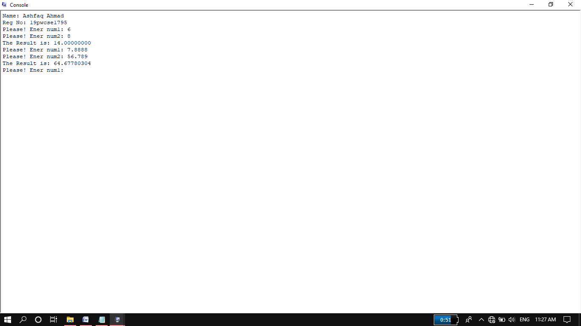

**Task 02:**

Write a program in Assembly language that subtracts two floating number.

**Source Code:**

.data

str: .asciiz"Name: Ashfaq Ahmad\nReg No: 19pwcse1795"

str1: .asciiz"\nPlease! Ener num1: "

str2: .asciiz"Please! Ener num2: "

str3: .asciiz"The Result is: "

.text

main:

li $v0,4 #string display

la $a0,str

syscall

repeat:

li $v0,4

la $a0,str1

syscall

li $v0,6

syscall

mov.s $f1,$f0

li $v0,4

la $a0,str2

syscall

li $v0,6

syscall

mov.s $f2,$f0

sub.s $f3,$f1,$f2

li $v0,4 #string display

la $a0,str3

syscall

li $v0,2

mov.s $f12,$f3

syscall

j repeat

li $v0,10

syscall

**Output:**

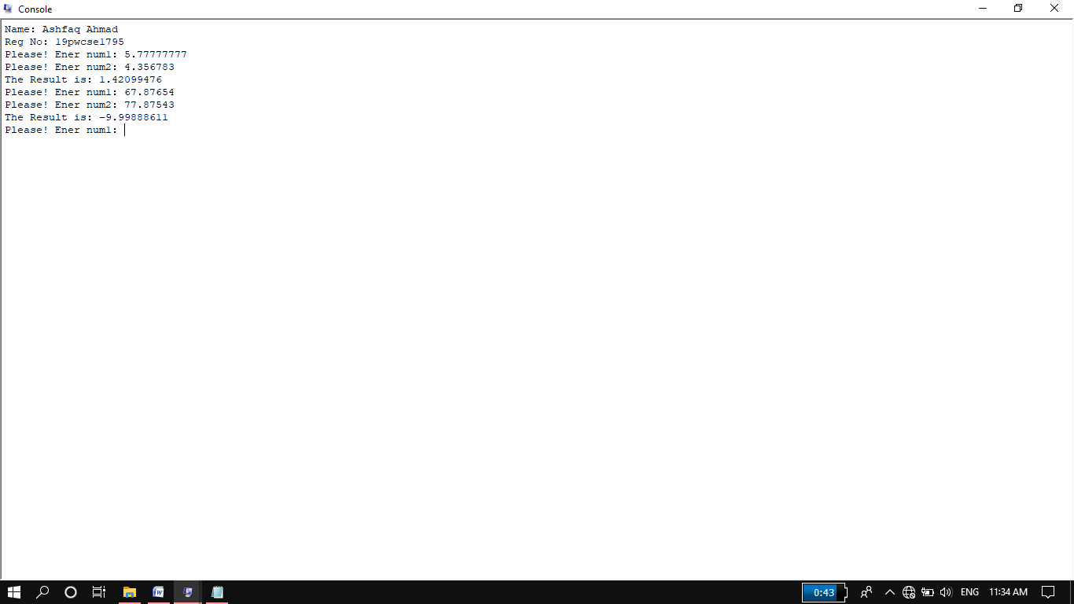

**Task 03:**

Write a program in Assembly language that Multiply two floating number.

**Source Code:**

.data

str: .asciiz"Name: Ashfaq Ahmad\nReg No: 19pwcse1795"

str1: .asciiz"\nPlease! Ener num1: "

str2: .asciiz"Please! Ener num2: "

str3: .asciiz"The Result is: "

.text

main:

li $v0,4 #string display

la $a0,str

syscall

li $v0,4

la $a0,str1

syscall

li $v0,6

syscall

mov.s $f1,$f0

li $v0,4

la $a0,str2

syscall

li $v0,6

syscall

mov.s $f2,$f0

mul.s $f3,$f1,$f2

li $v0,4 #string display

la $a0,str3

syscall

li $v0,2

mov.s $f12,$f3

syscall

li $v0,10

syscall

**Output:**

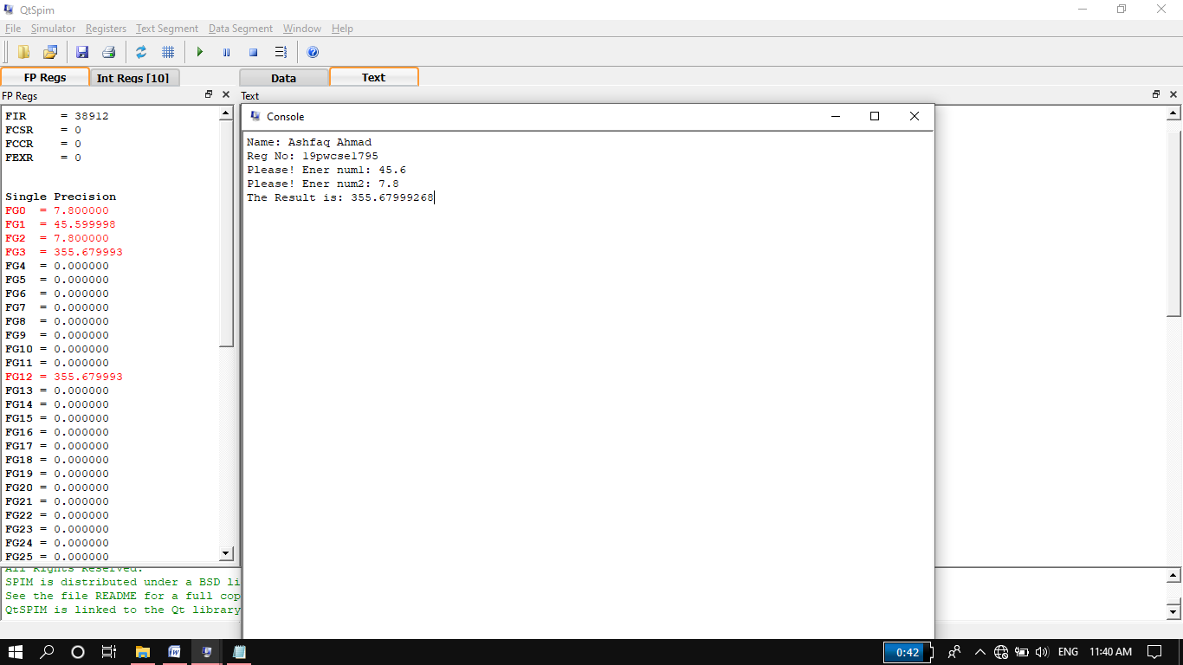

**Task 04:**

Write a program in Assembly language that converts temperature from centigrade to Fahrenheit.

(°C × 9/**5**) + 32 = °F

**Source Code:**

.data

str: .asciiz"Name: Ashfaq Ahmad\nReg No: 19pwcse1795"

str1: .asciiz"\nPlease! Ener Temperature in Centigrate: "

str2: .asciiz"The Temprature in Fehranheit is: "

#in case of doubble precision all even register is used from 2 to 30 for storing data.

.text

main:

li $v0,4 #string display

la $a0,str

syscall

repeat:

li $v0,4 #string display

la $a0,str1

syscall

li $v0,7 # 7 for inputing doubble precision floating number

syscall

mov.d $f2,$f0

li.d $f4,9.0

li.d $f6,5.0

li.d $f8,32.0

div.d $f10,$f4,$f6

mul.d $f14,$f2,$f10

add.d $f16,$f14,$f8

li $v0,4 #string display

la $a0,str2

syscall

li $v0,3 # 3 is used to display double precision floating number on monitor screen.

mov.d $f12,$f16

syscall

j repeat

li $v0,10

syscall

**Output:**

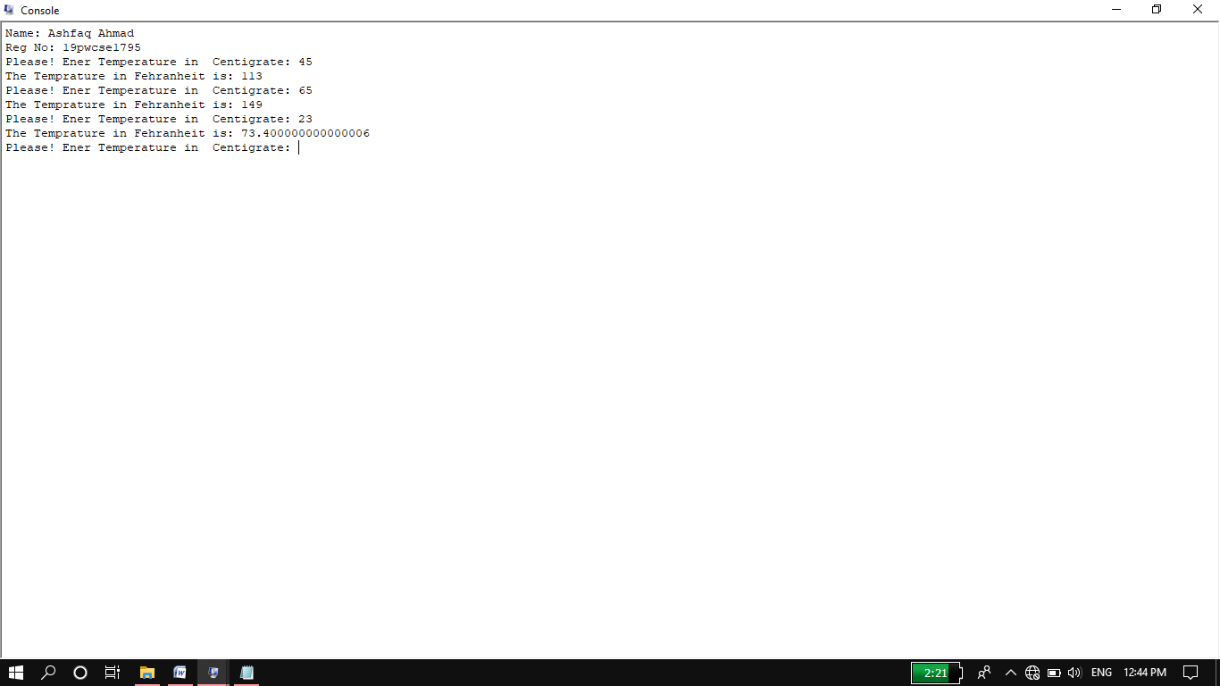

**Task 05:**

Create a GPA calculator that calculates your GPA in four subjects. The program should take GPA and credit hours of each subject and will print the final GPA in 4 subjects.

**Source Code:**

.data

str: .asciiz"***************** GPA CALCULATOR *******************\n\n"

str1: .asciiz"Name: Ashfaq Ahmad \nReg No: 19pwcse1795\n\n"

str2: .asciiz"Please! Enter GPA in Subject 1: "

str3: .asciiz"\nPlease! Enter GPA in Subject 2: "

str4: .asciiz"\nPlease! Enter GPA in Subject 3: "

str5: .asciiz"\nPlease! Enter GPA in Subject 4: "

str6: .asciiz"Please! Enter Credit Hours: "

str7: .asciiz"\n\nYour GPA in 4 subjects is: "

.text

main:

li $v0,4 #string display

la $a0,str

syscall

li $v0,4 #string display

la $a0,str1

syscall

li $v0,4 #string display

la $a0,str2

syscall

li $v0,6 #for putting gpa subject 1

syscall

mov.s $f1,$f0

li $v0,4 #string display

la $a0,str6

syscall

li $v0,6 #for putting credit hour subject 1

syscall

mov.s $f2,$f0

li $v0,4 #string display

la $a0,str3

syscall

li $v0,6 #for putting gpa subject 2

syscall

mov.s $f3,$f0

li $v0,4 #string display

la $a0,str6

syscall

li $v0,6 #for putting credit hour subjec 2

syscall

mov.s $f4,$f0

li $v0,4 #string display

la $a0,str4

syscall

li $v0,6 #for putting gpa subject 3

syscall

mov.s $f5,$f0

li $v0,4 #string display

la $a0,str6

syscall

li $v0,6 #for putting credit hour subject 3

syscall

mov.s $f6,$f0

li $v0,4 #string display

la $a0,str5

syscall

li $v0,6 #for putting gpa subject 4

syscall

mov.s $f7,$f0

li $v0,4 #string display

la $a0,str6

syscall

li $v0,6 #for putting credit hour subject 4

syscall

mov.s $f8,$f0

mul.s $f9,$f1,$f2 #credit hours * subject gpa

mul.s $f10,$f3,$f4

mul.s $f11,$f5,$f6

mul.s $f13,$f7,$f8

add.s $f14,$f9,$f10

add.s $f15,$f11,$f13

add.s $f16,$f14,$f15 # f16=sum of all CH*SGPA

add.s $f17,$f2,$f4

add.s $f18,$f6,$f8

add.s $f19,$f17,$f18 # f19=sum of all credit hour

div.s $f12,$f16,$f19 # sum of all CH*SGPA divided by sum of all credit hour.

li $v0,4 #string display

la $a0,str7

syscall

li $v0,2 #single precision number display on monitor screen.

syscall

li $v0,10

syscall

**Output:**

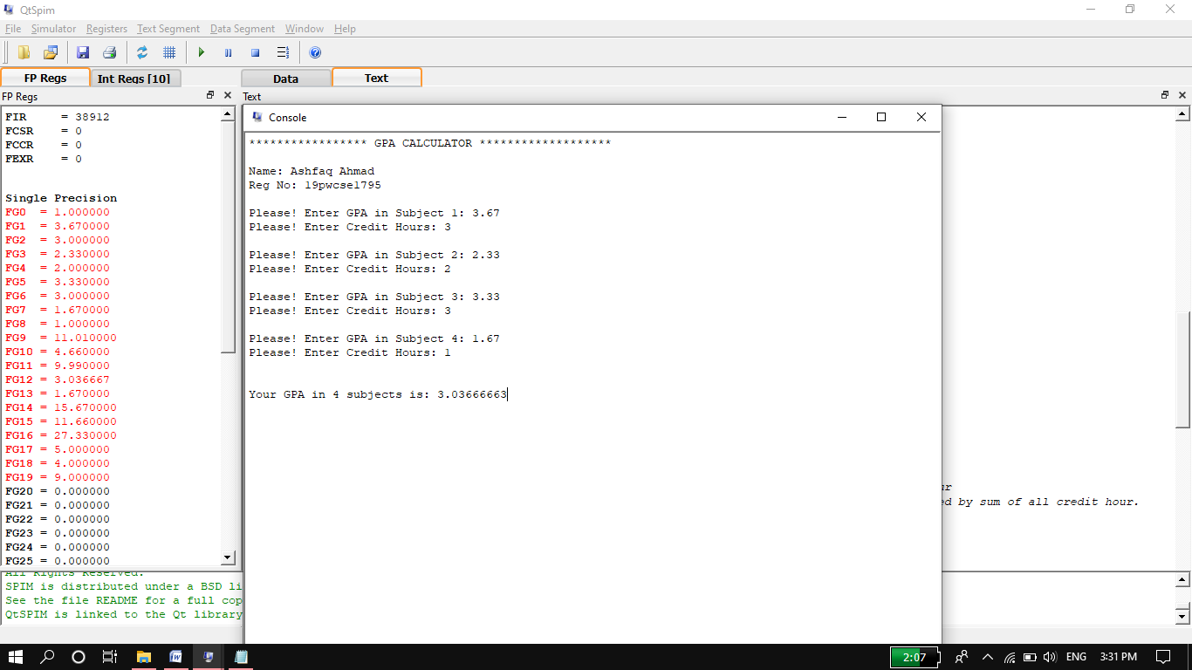

**Task 06:**

Create a simple calculator in Assembly language that performs addition, subtractions, multiplication and Division.

**Source Code:**

.data

str: .asciiz"Name: Ashfaq Ahmad \nReg No: 19pwcse1795\n"

str1: .asciiz"\n\nPlease Enter Num1: "

str2: .asciiz"please Enter Num2: "

str3: .asciiz"Please Enter an operator:"

str4: .asciiz"\nThe sum is: "

str5: .asciiz"\nThe subtraction is: "

str6: .asciiz"\nThe multiplication is: "

str7: .asciiz"\nThe division is: "

.text

main:

li $v0,4 #print string

la $a0,str

syscall

loop:

li $v0,4 #print string

la $a0,str1

syscall

li $v0,7 #7 for input doubble precision

syscall

mov.d $f2,$f0

li $v0,4 #print string

la $a0,str2

syscall

li $v0,7 # 7 for input doubble precision

syscall

mov.d $f4,$f0

li $v0,4 #print string

la $a0,str3

syscall

li $v0,12 # 12 input ascci

syscall

move $t1,$v0

li $t2,43 # + operator

li $t3,45 # - operator

li $t4,42 # * operator

li $t5,47 # / operator

beq $t1,$t2, addition

beq $t1,$t3, subtraction

beq $t1,$t4, multiplication

beq $t1,$t5, division

addition:

add.d $f12,$f2,$f4

li $v0,4

la $a0,str4

syscall

li $v0,3 # 3 for doubbble result display.

syscall

j exit

subtraction:

sub.d $f12,$f2,$f4

li $v0,4

la $a0,str5

syscall

li $v0,3 # 3 for doubbble result display.

#mov.d $f6,$f6

syscall

j exit

multiplication:

mul.d $f12,$f2,$f4

li $v0,4

la $a0,str6

syscall

li $v0,3 # 3 for doubbble result display.

#mov.d $f6,$f6

syscall

j exit

division:

div.d $f12,$f2,$f4

li $v0,4

la $a0,str7

syscall

li $v0,3 # 3 for doubbble result display.

#mov.d $f12,$f6

syscall

exit:

j loop

li $v0,10

syscall

**Output:**

